

WEB SCRIPTING

CSE – 220 QUARTER V



September 30, 2020

M.Sathishkumar

E0119052

**Challenge 1:**

**Code for get method**

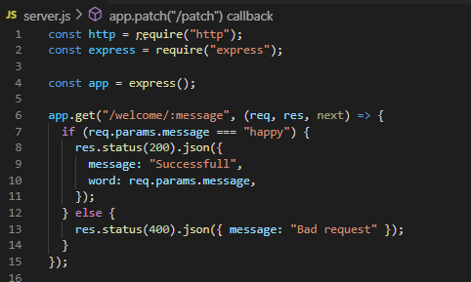

**Result:**

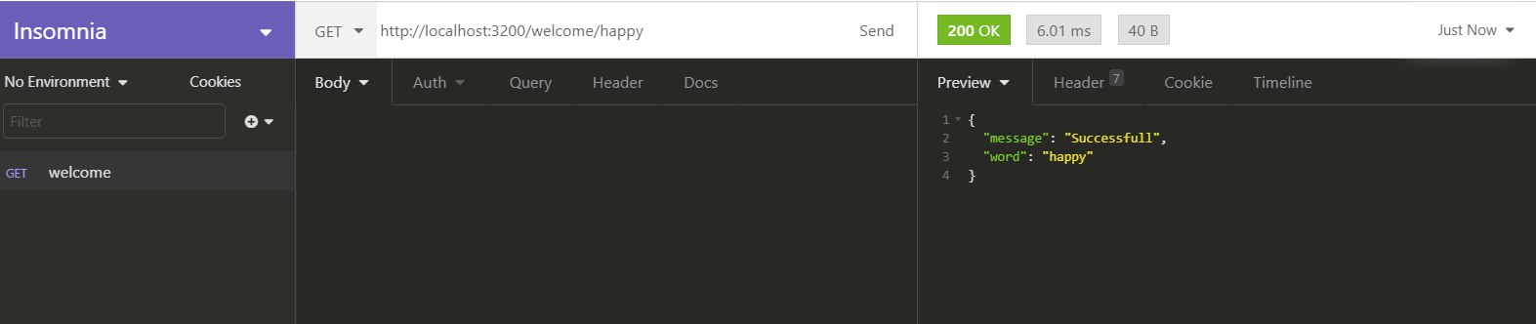

**Code for post method**

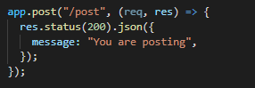

**Result**

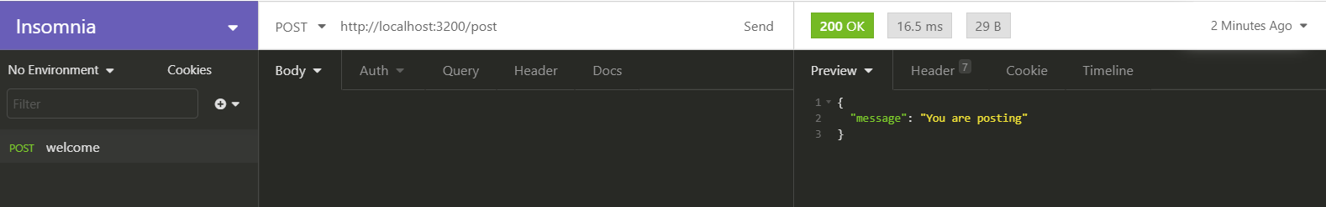

**Code for patch method**

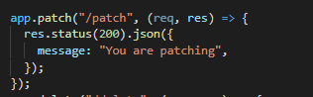

**Result**

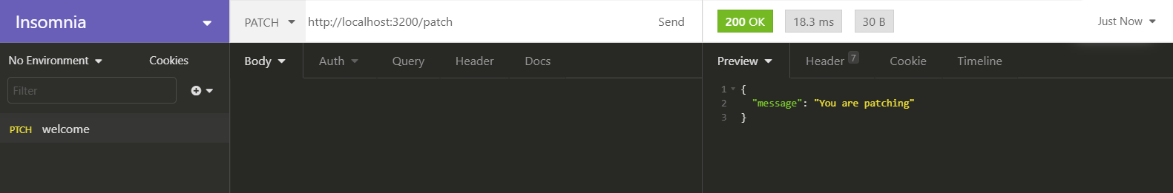

**Code for delete method**

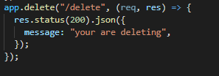

**Result**

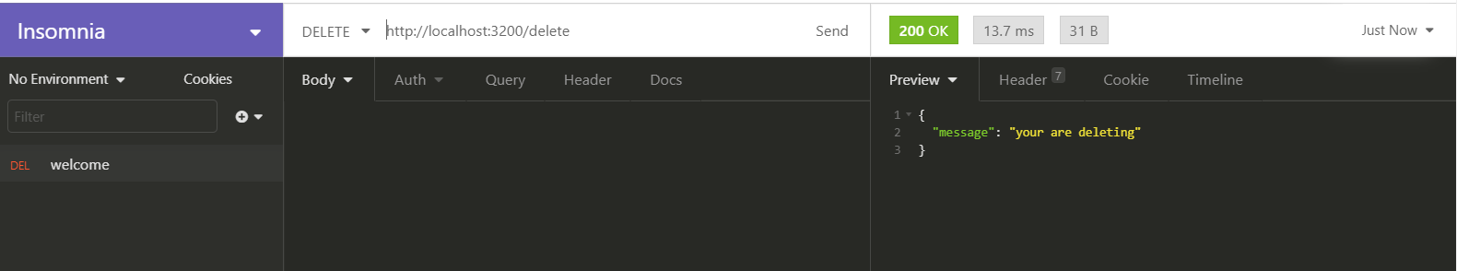

**Code for error exception**

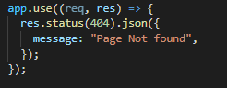

**Result**

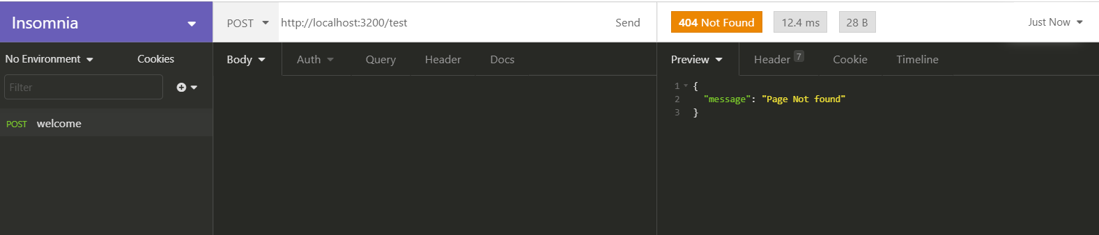

**Listing server port:**

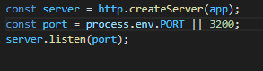

**My Project Code**

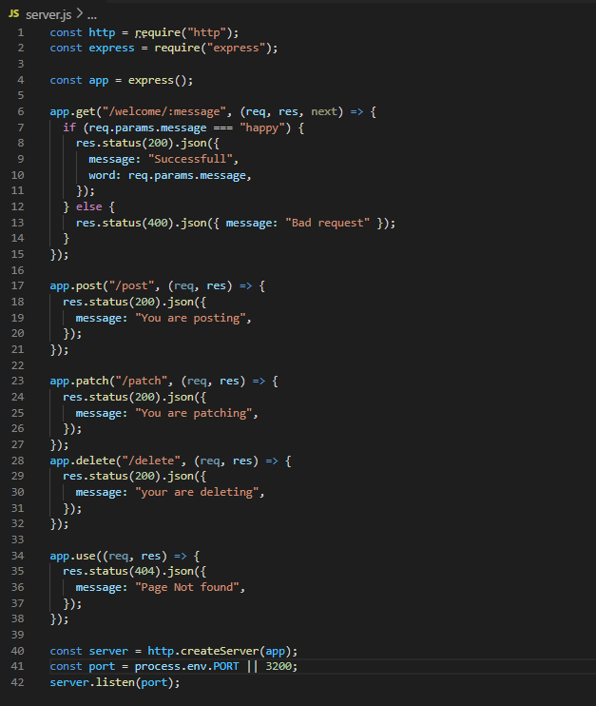

Connecting Express with Mongo and performing page routing

* **DB Connection:**

